FOR IMMEDIATE RELEASE

VESA DisplayHDR Standards for LCD and OLED Displays Continue to Gain Momentum and Will Be Highlighted at SID Display Week 2019 Show

More than 60 display products across 13 display OEMs have achieved DisplayHDR certification to date; VESA to also showcase developments in video compression and automotive video interfaces

SAN JOSE, Calif. – May 8, 2019 – The Video Electronics Standards Association (VESA®) today announced that rising consumer demand for displays that provide more brilliant, life-like picture quality, as well as greater brightness and contrast levels, and a wider range of colors, is fueling adoption of its DisplayHDR standard. To date, more than 60 display products across 13 display OEMs have been released to market that have achieved DisplayHDR certification, with more expected to be introduced in the coming months. First introduced in December 2017, DisplayHDR is the display industry’s first fully open standard specifying high dynamic range (HDR) quality for LCD displays.
VESA Certified DisplayHDR brand logo.
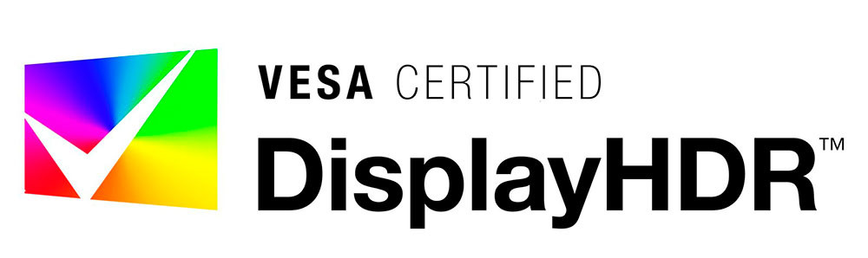

In addition to the growing adoption of DisplayHDR for LCD displays, including the first DisplayHDR laptops from Lenovo and ASUS, VESA is also seeing continued momentum behind its new DisplayHDR True Black standard for OLED and other emissive displays. Since DisplayHDR True Black was announced this past January, Samsung Display has introduced OLED panels for notebooks and laptops that meet the new VESA specification, while HP has launched the first DisplayHDR True Black laptop. DisplayHDR True Black addresses the need for significantly deeper black performance levels, for applications such as home theater and gaming in subdued lighting environments.

VESA Certified DisplayHDR True Black brand logo.

VESA will highlight these and other major developments with its display standards – including support for beyond-8K resolutions, augmented/virtual reality (AR/VR), higher display compression rates and high-resolution automotive displays – at SID’s Display Week 2019 symposium and conference, taking place at the San Jose Convention Center in San Jose, Calif., May 12-17. Demonstrations will include:

VESA Highlights Strong Momentum for DisplayHDR Standards at Display Week 2019………….Page 2 of 3

- High Dynamic Range – VESA will showcase a variety of commercially available and soon-to-be-released LCD monitors and laptops for the gaming, enthusiast, and professional industries that highlight the high contrast ratio, color accuracy and vibrancy enabled by HDR and incorporating VESA’s DisplayHDR standard. These include side-by-side comparisons of displays certified at different performance tiers, as well as the new DisplayHDR-certified ASUS ROG ZEPHYRUS S GX701GXR gaming laptop.

- Visually Lossless Video Compression – A demo of VESA’s latest display interface compression standard VDC-M will be on hand, highlighting the remarkable picture quality of VDC-M compression at various bit rates, all the way from 12 bits per pixel (bpp) to 4 bpp. Another demo will highlight the full capability of DisplayPort 1.4a to handle the transport of video content compressed with the latest version of Display Stream Compression (DSC). With DSC, multiple ultra-high-definition video streams can be transported across a single DisplayPort interface or USB Type-C connector. DisplayPort 1.4a FEC (Forward Error Correction) is used with the compressed video stream to ensure a completely glitch-free visual experience.

- Embedded DisplayPort for Automotive – VESA will show a proof-of-concept demo on the implementation of VESA’s Embedded DisplayPort (eDP) standard as a video interface and transport for high-resolution display panels for automotive applications. LVDS, which is the current video interface that has been widely adopted in the automotive display market, is generally limited to 1080p resolution, and is unable to support the market trend toward higher resolution (e.g., 4K) automotive displays.

Open HDR Standards a Win-Win for Consumers and Manufacturers
The DisplayHDR and DisplayHDR True Black specifications from VESA provide important benefits for manufacturers and consumers alike. For PC makers, the standards provide consistent, measurable HDR performance parameters to support the development of their products. At the same time, consumers have an HDR rating number and logo system that is meaningful and reflects actual performance.

According to Bill Lempesis, executive director at VESA, “Since its introduction more than a year ago, the DisplayHDR specification has seen strong adoption among consumers as well as support from across the industry. Over two dozen companies, including major OEMs that make displays, graphic cards and CPUs, have been involved in its development and continue to work with VESA in refining and tightening the spec to improve the user experience and address the evolving needs of the industry. A case in point is our recent introduction of the DisplayHDR True Black standard for OLED and emissive PC and notebook displays, which is also seeing robust momentum and interest.”

VESA Highlights Strong Momentum for DisplayHDR Standards at Display Week 2019………….Page 3 of 3

Note to Attendees at Display Week 2019
Attendees interested in learning more about VESA and its family of standards are invited to visit VESA at the DisplayPort booth #641 on May 14-16 at the San Jose Convention Center.

In addition, Craig Wiley, senior director of marketing for Parade Technologies and board member at VESA, will present on new VESA standards developments in his talk “Enabling display innovations through new developments in open industry standards” at the Exhibitors Forum at Display Week on Tuesday, May 14 at 11:00 a.m. in the Executive Ballroom in the San Jose Convention Center.

More information on DisplayHDR and DisplayHDR True Black, including certified monitors and laptops, is available at https://displayhdr.org/.

About VESA
The Video Electronics Standards Association (VESA) is an international, non-profit standards association representing a global network of more than 280 hardware, software, computer, display and component manufacturers committed to developing and promoting the electronics industry. For 30 years, VESA has created and supported simple, universal and cross-product solutions for today’s video and electronics industry. The association’s standards include DisplayPort™, the industry replacement for DVI, LVDS and VGA. DisplayPort utilizes a state-of-the-art digital protocol and provides an expandable foundation to enable astonishing digital display experiences. For more information on VESA, please visit http://www.vesa.org/.

VESA® is a registered trademark and DisplayPort™ is a trademark of VESA. All other trademarks, service marks, registered trademarks, and registered service marks are the property of their respective owners.

Contacts:
Bill Lempesis David Moreno
Executive Director Principal
VESA Open Sky Communications
Tel: (408) 982-3850 Tel: (415) 519-3915
E-mail: bill@vesa.org E-mail: dmoreno@openskypr.com

# # #

