Editorial contact:
Press Release
Bill Maurer – Macrovision, Inc.
(215) 348-1010 | bill@macrovis.com

The Tianma Group introduces a new freeform display for automotive applications
Chino, CA, May 16, 2018 – The Tianma Group has developed a new “freeform” display module, designed to allow for greater flexibility and creativity in integrating digital display technology with established analog elements. Tianma will demonstrate a freeform automotive module with inner holes and ultra-narrow border at Display Week 2018.
Tianma’s freeform display is achieved using VGIA (Virtual Gate Inline Pixel Array) technology to create a gate fan outline in the display active area without circuits added to the left and right borders of the display. By applying these technology advances, Tianma can create displays in virtually any shape a customer desires.
Ideal for automotive applications such as in-dash instrument clusters, the 12.3-inch a-Si HD freeform slim module with inner-holes and an ultra-narrow border was developed by Tianma Micro-electronics Co. In this design, the holes in the left and right sides of the unit allow for easy incorporation of a mechanical pointer with the LCD display background.
Tianma achieved a narrow 1.1-mm border by utilizing the freeform process and VGIA technology. The 12.3” freeform module also eliminates “V” mura (cloudiness) around the hole.
 | 12.3" Freeform / Ultra-narrow Border
Outline Dimension (mm) | 294.08×120.76×3.50
Active Area (mm) | 291.46×109.30
Resolution (pixel) | 1920×720
Luminance (cd/m²) | 800
Contrast Ratio | 1200:1
Dimensions (mm) | 1.1 / 1.1 (Border, U/L/R)
Interface | LVDS
Operating Temp. | -40°C~+85°C
Storage Temp. | -40°C~+95°C
Application | Automotive
Status | Prototype

The new automotive freeform display technology, along with The Tianma Group’s expansive family of displays and technologies, will be showcased at Display Week 2018, May 22 to 24 in Los Angeles, California, USA, in Booth 1005.
For more information, contact Tianma America, Inc., 13949 Central Ave., Chino, CA 91710. 909-590-5833. info@tianma.com; www.tianma.com.
  - 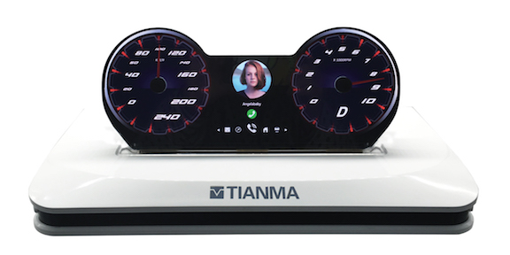
Caption: The Tianma Group has introduced a new Freeform Display Module for Automotive Applications. Photo: Tianma America, Inc.
###
About Tianma America, Inc.
Tianma America (TMA) is the leading provider of small- to medium-size display solutions to the Americas market utilizing advanced technologies and manufacturing resources of the Tianma Group Companies, which includes Tianma Micro-electronics (Shenzhen and Shanghai) and Tianma Japan, Ltd. (formerly known as NLT Technologies Ltd.), as well as manufacturing locations in Chengdu, Wuhan, Xiamen, Shenzhen and Shanghai China. Tianma America technologies can be found in smartphones, tablet PCs, industrial and medical instrumentation, wearables, home automation, household appliances, office equipment, and automotive and rear seat entertainment devices. Additional applications include test and measurement systems, instrumentation equipment, point-of-sale and ATM systems, gaming systems, global positioning systems, radio-frequency identification devices and barcode scanners.
Tianma America’s technology portfolio comprises TFT, LTPS, Oxide-TFT, AM-OLED, flexible, transparent, 3D, PCAP and In-cell/On-cell integrated touch. With a network of best-in-class distributors and value-added partners, Tianma America provides complete display module solutions for a broad base of customers and applications.
The content in this press release, including, but not limited to, product prices and specifications, is based on the information as of the date indicated on the document, but may be subject to change without prior notice.

