Editorial contact:
Press Release
Bill Maurer – Macrovision, Inc.
(215) 348-8109 | bill@macrovis.com

Tianma showcasing wide range of new display products and prototype technologies at Display Week 2019

Demos include AMOLED, LTPS, Micro LED and touch technologies for the automotive, consumer and industrial market segments

San Jose, CA, May 14, 2019 – Tianma, a leading global manufacturer of flat panel displays, will be exhibiting a wide variety of new display technologies at Display Week 2019, Booth 1007, San Jose, California, May 14-16.

Tianma will be showcasing approximately 50 display demonstration units, including new prototypes and recently introduced products. In addition, Tianma has entered several new cutting-edge products and technologies into SID’s annual Display Industry Awards and the new People's Choice (formerly Best in Show) competitions, the winners of which will be recognized at a luncheon on Wednesday, May 15, honoring the best product, component, and application of the preceding year as well as the best products at Display Week.

Tianma’s featured products at Display Week 2019 will include:

7.56” Micro LED (People’s Choice Award Nominee) – Tianma has developed the world's first Micro LED display with over 60% transparency and a resolution of 720*480 (114PPI), along with an ultra-thin border of less than 0.8mm (left and right). Compared to OLED, Tianma’s Micro LED display is better suited for automotive applications due to its high image stability and longer life. The transparent Micro LED display is ideal for use in a HUD or car window application.

LTPS Mini LED High Dynamic Range (HDR) LCD (People’s Choice Award Nominee) – Tianma’s LTPS Mini LED HDR LCD is an advanced technology for mobile phone applications, capable of accurately reproducing life-like images comparable at a performance level to that of OLED technology. With the Mini LED driven by AM-TFT, this allows for an ultra-high number of local dimming zones (4,608). Tianma’s LTPS Mini LED HDR LCD achieves the following performance benchmarks: dynamic CR 20,000:1~1,000,000:1; max. brightness of 800nits; minimal light leakage; and NTSC at 96%, making this an ideal solution for outdoor and high ambient light conditions.

Robot Face with Flexible AMOLED (People’s Choice Award Nominee) – Tianma has applied its flexible AMOLED display to a robotic Sichuan Opera Face, an ancient Chinese dramatic art involving colored masks. The unique design and application with its flexible AMOLED bendable qualities highlight Tianma’s advanced technology capabilities. This light and thin full-screen display features an out-folding radius of 5 mm and can withstand 200,000 bending cycles.

SLT Technology – The Tianma Group has developed a new technology designed to allow LCDs to function normally in extremely low temperatures, down to -45 deg. C. Labeled SLT (Super Low Temperature), this technological advancement adopts a proprietary new design scheme, process and materials, all to solve the response time and ghosting problems inherent with traditional LCDs.

PCAP Touch Technology Portfolio – The Tianma Group has dedicated extensive resources to in-house development and manufacturing capabilities, ensuring ongoing advancement of its PCAP (Projected Capacitive) Touch technology. With these continuous improvements, Tianma can offer high quality, integrated PCAP solutions across numerous applications. In addition to providing customers with a variety of touch technologies, Tianma can also provide customers with a wide range of value-added services.

Tianma’s PCAP portfolio includes: Optical Bonding Technology; Wet & Glove Technology; Touch Embedded Display (TED) Technology; On-cell Touch Technology; Force Touch Technology; 3D Touch Technology; Active/Passive Stylus Pen Technology; and Multimodal Tactile Feedback.

AMOLED Technology Portfolio – Tianma will feature a breadth of AMOLED products and technology demos showcasing the company’s capabilities including: Smart Module; Foldable (fixed, in-folding and out-folding); Foldable + TED Plus touch technology; Rigid + TED Plus / Full-Screen; Rigid + Fingerprint recognition; Printing AMOLED; and Auto AMOLED.

Along with the display prototypes and new product introductions, Tianma will also be exhibiting a variety of products from their standard line-up. Technologies featured include: PCAP, In-Cell touch, LTPS, OLED, high resolution, wide viewing angle, outdoor viewable, wide format and high bright a-Si TFT display products, including products specifically designed for key display applications such as: mobile, wearable, automotive, avionics, home automation, HMI, FA, POS and medical.

More information about the innovative new display solutions being displayed by Tianma is available at Booth 1007 at Display Week and in the Tianma Group press kits, accessible online at http://sid.vporoom.com/Tianma

Additional information can be found at usa.tianma.com.

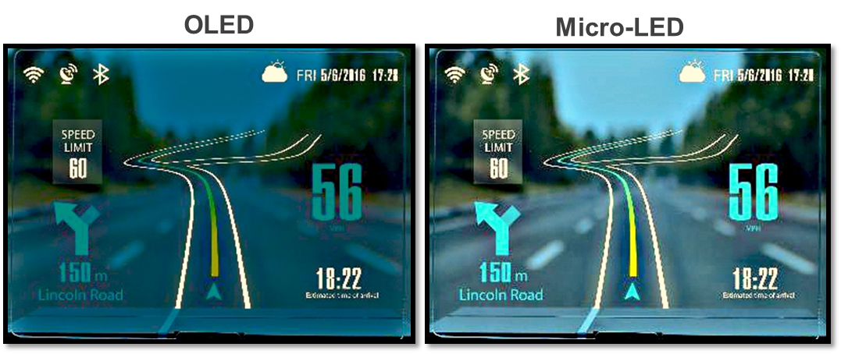
Tianma 7.56” Micro LED

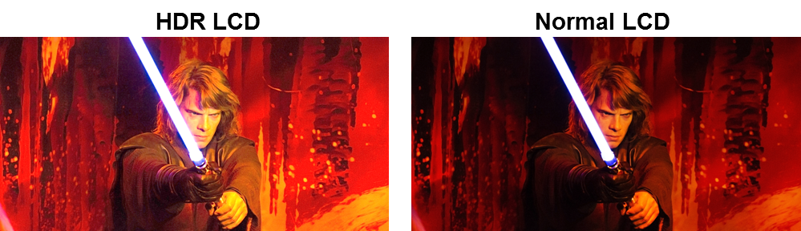
Tianma LTPS Mini LED High Dynamic Range (HDR) LCD

Robot Face with Flexible AMOLED

Tianma SLT Technology

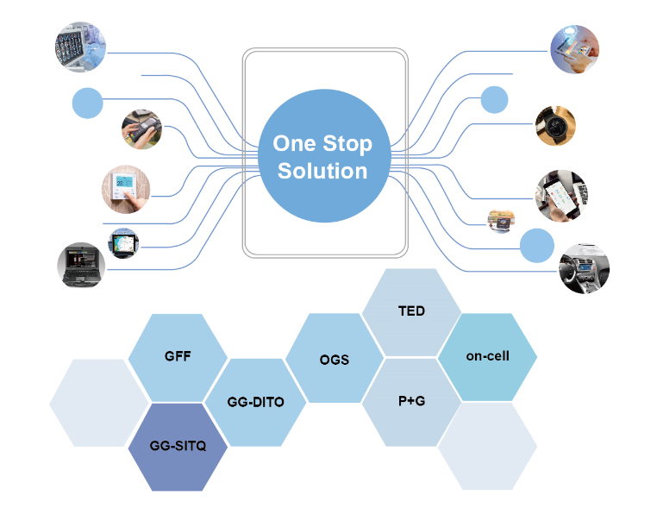
Tianma PCAP Touch Solutions

###

About Tianma America, Inc.
Tianma America (TMA) is the leading provider of small- to medium-size display solutions to the Americas market utilizing advanced technologies and manufacturing resources of the Tianma Group Companies, which includes Tianma Micro-electronics (Shenzhen and Shanghai) and Tianma Japan, Ltd. (formerly known as NLT Technologies Ltd.), as well as manufacturing locations in Chengdu, Wuhan, Xiamen, Shenzhen and Shanghai China. Tianma America technologies can be found in smartphones, tablet PCs, industrial and medical instrumentation, wearables, home automation, household appliances, office equipment, and automotive and rear seat entertainment devices. Additional applications include test and measurement systems, instrumentation equipment, point-of-sale and ATM systems, gaming systems, global positioning systems, radio-frequency identification devices and barcode scanners.

Tianma America’s technology portfolio comprises TFT, LTPS, Oxide-TFT, AM-OLED, flexible, transparent, 3D, PCAP and In-cell/On-cell integrated touch. With a network of best-in-class distributors and value-added partners, Tianma America provides complete display module solutions for a broad base of customers and applications.

The content in this press release, including, but not limited to, product prices and specifications, is based on the information as of the date indicated on the document, but may be subject to change without prior notice.

